|  |
| --- |
| 新东方在线英语学习 |
| 新概念 1 册 |
| Lesson39-40 |



扫一扫。更多有趣的英语资讯。

# Lesson 39 单词讲解

1. front: n. 前面
2. in front of: 在…之前

in the front of

The man is in front of the car.外部前面

The man is in the front of the car.内部前面

1. careful: 小心的，仔细的
2. vase: 花瓶wa si

vases 复数wa si ei si

1. drop: v. 掉下
2. flower: 花fu lai wo er

flowers 复数

# Lesson 39 课文讲解

1. What are you going to do with… ?

你打算怎么处理…? What are you going to do with the old books?

1. Give it to me.
   1. 祈使句
      1. 没有主语
      2. 动词打头

Come in.

Shut the door. Open the window. Air the room…

Be careful!

be+ adj.\ prep. … Be happy!

Be good!

Be nice!

* 1. Give it to me.

You give the vase to me. 主 谓 宾 宾双宾语

give \ show \ take \teach… You give the vase to me.

主 谓 宾 宾You give me the vase. 主 谓 宾 宾

the vase: sth. me: sb.

give sth. to sb.= give sb. sth. give sth. to sb.= give sb. sth.

I give some money to him.

= I give him some money.

I give a flower to my mother.

= I give my mother a flower. give sth. to sb.= give sb. sth. 我给了他们一些新书。

I give them some new books.

I give some new books to them.

我给了她一只猫。

I give her a cat.

I give a cat to her.

1. There we are.

瞧,看~

就这么着吧~

# Lesson 39 语法讲解

说不

1. 构成：is not/ am not/ are not

This is my name. This is not my name. She is pretty. She is not pretty.



You are busy.

I am in the front.

You are not busy.

I am not in the front.

2. Don’t（Do not） + v. （动词）

# Don’t smoke !

Do it! Don’t do it! Come in!

Don’t come in! Dust it!

Don’t dust it!

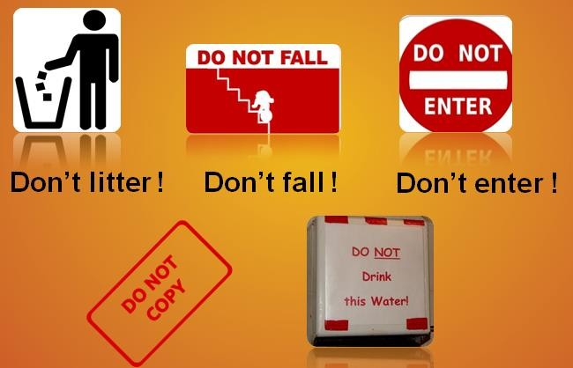

Don’t drop it！ Don’t do that! Don’t put it there! 不要工作啦！ Don’t work!

不要游泳啦！ Don’t swim! 不要开车啦！



Don’t drive!

不要吃啦！ Don’t eat it! 不要做饭啦！

Don’t cook!

# Lesson 40 单词句型讲解

1. show: v. 给…看
2. send: v. 送给
3. take: v. 带给接双宾语！

show sb. sth.= show sth. to sb. send sb. sth.= send sth. to sb. take sb. sth.= take sth. to sb.

我打算给我奶奶送一封信。

I’m going to send my grandma a letter.

I’m going to send a letter to my grandma. 我打算给我朋友展示一下我的新裙子。I’m going to show my friend my new dress.

I’m going to show my new dress to my friend.

# Lesson 39&40 知识拓展

